Carmen Leon
John Jay College of Criminal Justice
Capstone 2

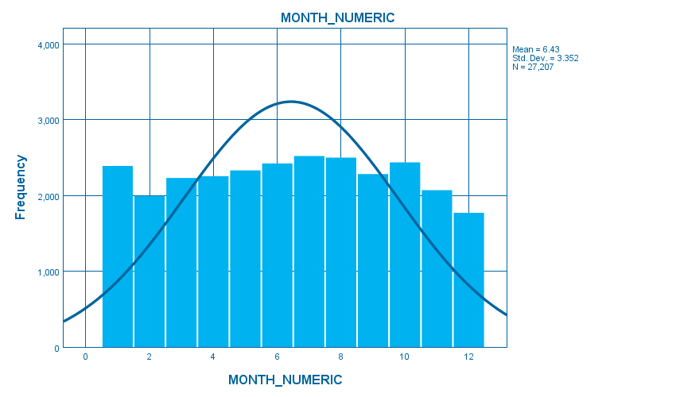
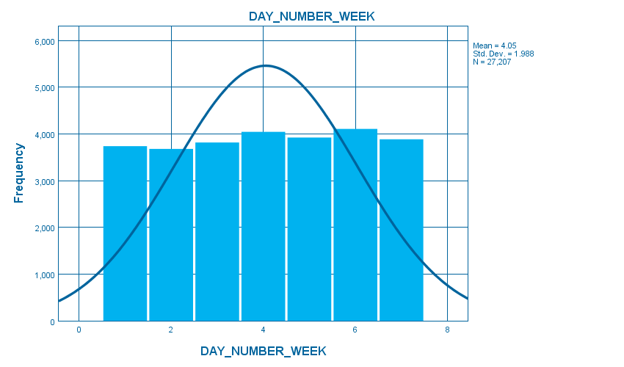

- Is felony crime distributed evenly across days, months, and seasons in your borough?

MONTH_NUMERICMONTH_NUMERIC, table, 1 levels of column headers and 2 levels of row headers, table with 6 columns and 15 rows
 |  | Frequency | Percent | Valid Percent | Cumulative Percent
Valid | January | 2390 | 8.8 | 8.8 | 8.8
Valid | February | 1994 | 7.3 | 7.3 | 16.1
Valid | March | 2232 | 8.2 | 8.2 | 24.3
Valid | April | 2255 | 8.3 | 8.3 | 32.6
Valid | May | 2331 | 8.6 | 8.6 | 41.2
Valid | June | 2422 | 8.9 | 8.9 | 50.1
Valid | July | 2521 | 9.3 | 9.3 | 59.3
Valid | August | 2500 | 9.2 | 9.2 | 68.5
Valid | September | 2283 | 8.4 | 8.4 | 76.9
Valid | October | 2437 | 9.0 | 9.0 | 85.9
Valid | November | 2070 | 7.6 | 7.6 | 93.5
Valid | December | 1772 | 6.5 | 6.5 | 100.0
Valid | Total | 27207 | 100.0 | 100.0

DAY_NUMBER_WEEKDAY_NUMBER_WEEK, table, 1 levels of column headers and 2 levels of row headers, table with 6 columns and 10 rows
 |  | Frequency | Percent | Valid Percent | Cumulative Percent
Valid | Sunday | 3740 | 13.7 | 13.7 | 13.7
Valid | Monday | 3681 | 13.5 | 13.5 | 27.3
Valid | Tuesday | 3819 | 14.0 | 14.0 | 41.3
Valid | Wednesday | 4047 | 14.9 | 14.9 | 56.2
Valid | Thursday | 3925 | 14.4 | 14.4 | 70.6
Valid | Friday | 4108 | 15.1 | 15.1 | 85.7
Valid | Saturday | 3887 | 14.3 | 14.3 | 100.0
Valid | Total | 27207 | 100.0 | 100.0

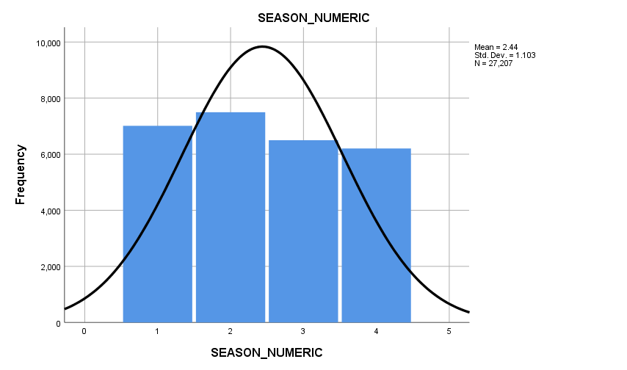
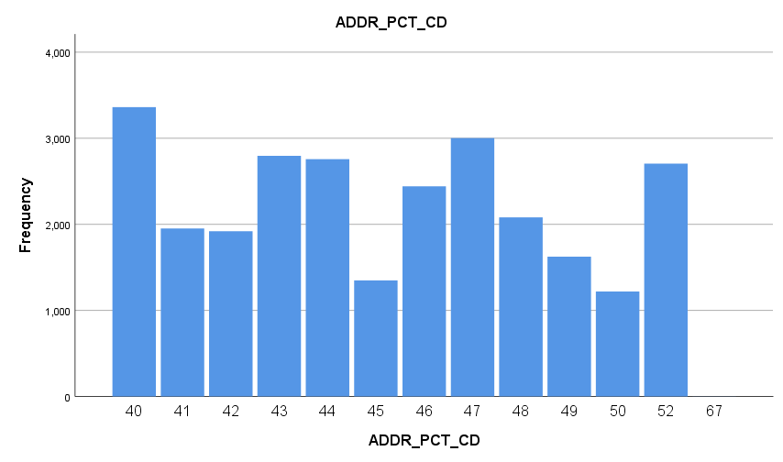
SEASON_NUMERICSEASON_NUMERIC, table, 1 levels of column headers and 2 levels of row headers, table with 6 columns and 7 rows
 |  | Frequency | Percent | Valid Percent | Cumulative Percent
Valid | Spring | 7011 | 25.8 | 25.8 | 25.8
Valid | Summer | 7495 | 27.5 | 27.5 | 53.3
Valid | Fall | 6498 | 23.9 | 23.9 | 77.2
Valid | Winter | 6203 | 22.8 | 22.8 | 100.0
Valid | Total | 27207 | 100.0 | 100.0

ADDR_PCT_CDADDR_PCT_CD, table, 1 levels of column headers and 2 levels of row headers, table with 6 columns and 16 rows
 |  | Frequency | Percent | Valid Percent | Cumulative Percent
Valid | 40 | 3361 | 12.4 | 12.4 | 12.4
Valid | 41 | 1952 | 7.2 | 7.2 | 19.5
Valid | 42 | 1920 | 7.1 | 7.1 | 26.6
Valid | 43 | 2795 | 10.3 | 10.3 | 36.9
Valid | 44 | 2757 | 10.1 | 10.1 | 47.0
Valid | 45 | 1349 | 5.0 | 5.0 | 51.9
Valid | 46 | 2442 | 9.0 | 9.0 | 60.9
Valid | 47 | 3002 | 11.0 | 11.0 | 72.0
Valid | 48 | 2080 | 7.6 | 7.6 | 79.6
Valid | 49 | 1624 | 6.0 | 6.0 | 85.6
Valid | 50 | 1219 | 4.5 | 4.5 | 90.1
Valid | 52 | 2705 | 9.9 | 9.9 | 100.0
Valid | 67 | 1 | .0 | .0 | 100.0
Valid | Total | 27207 | 100.0 | 100.0

Which precincts have the highest crime values? Precincts 40 has the highest crime values.

Are certain felony crimes seasonal? What crimes show an increase in warmer seasons?

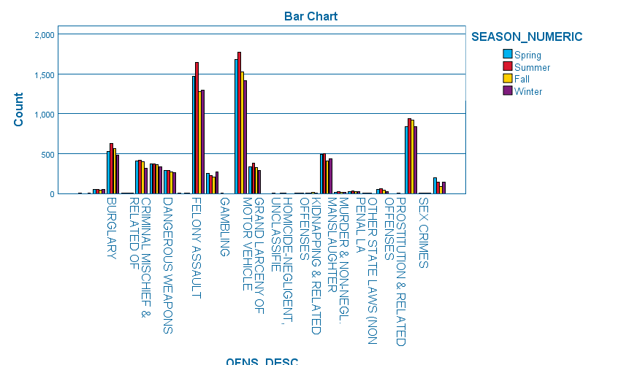

OFNS_DESC * SEASON_NUMERIC CrosstabulationOFNS_DESC * SEASON_NUMERIC Crosstabulation, table, Count, 1 layers, 2 levels of column headers and 2 levels of row headers, table with 7 columns and 31 rows
Count

 |  | SEASON_NUMERIC |  |  |  | Total
 |  | Spring | Summer | Fall | Winter | Total
OFNS_DESC |  | 2 | 0 | 0 | 1 | 3
OFNS_DESC | ARSON | 51 | 55 | 46 | 48 | 200
OFNS_DESC | BURGLARY | 529 | 628 | 566 | 485 | 2208
OFNS_DESC | CHILD ABANDONMENT/NON SUPPORT | 2 | 1 | 1 | 1 | 5
OFNS_DESC | CRIMINAL MISCHIEF & RELATED OF | 407 | 413 | 398 | 314 | 1532
OFNS_DESC | DANGEROUS DRUGS | 370 | 370 | 361 | 332 | 1433
OFNS_DESC | DANGEROUS WEAPONS | 287 | 293 | 272 | 258 | 1110
OFNS_DESC | ENDAN WELFARE INCOMP | 1 | 0 | 1 | 1 | 3
OFNS_DESC | FELONY ASSAULT | 1474 | 1644 | 1279 | 1299 | 5696
OFNS_DESC | FORGERY | 250 | 223 | 206 | 267 | 946
OFNS_DESC | GAMBLING | 1 | 0 | 0 | 0 | 1
OFNS_DESC | GRAND LARCENY | 1679 | 1768 | 1525 | 1417 | 6389
OFNS_DESC | GRAND LARCENY OF MOTOR VEHICLE | 331 | 384 | 328 | 285 | 1328
OFNS_DESC | HOMICIDE-NEGLIGENT-VEHICLE | 0 | 0 | 0 | 1 | 1
OFNS_DESC | HOMICIDE-NEGLIGENT,UNCLASSIFIE | 0 | 1 | 1 | 0 | 2
OFNS_DESC | KIDNAPPING | 0 | 2 | 1 | 2 | 5
OFNS_DESC | KIDNAPPING & RELATED OFFENSES | 5 | 6 | 11 | 6 | 28
OFNS_DESC | MISCELLANEOUS PENAL LAW | 494 | 502 | 408 | 438 | 1842
OFNS_DESC | MURDER & NON-NEGL. MANSLAUGHTER | 11 | 23 | 18 | 15 | 67
OFNS_DESC | NYS LAWS-UNCLASSIFIED FELONY | 27 | 37 | 26 | 26 | 116
OFNS_DESC | OTHER STATE LAWS (NON PENAL LA | 1 | 1 | 1 | 0 | 3
OFNS_DESC | POSSESSION OF STOLEN PROPERTY | 52 | 60 | 38 | 28 | 178
OFNS_DESC | PROSTITUTION & RELATED OFFENSES | 0 | 0 | 1 | 0 | 1
OFNS_DESC | ROBBERY | 837 | 937 | 924 | 835 | 3533
OFNS_DESC | SEX CRIMES | 6 | 6 | 2 | 2 | 16
OFNS_DESC | THEFT-FRAUD | 194 | 141 | 84 | 142 | 561
Total |  | 7011 | 7495 | 6498 | 6203 | 27207

4. Is felony crime distributed evenly across times of day? Which time of day had the highest felony incidents?

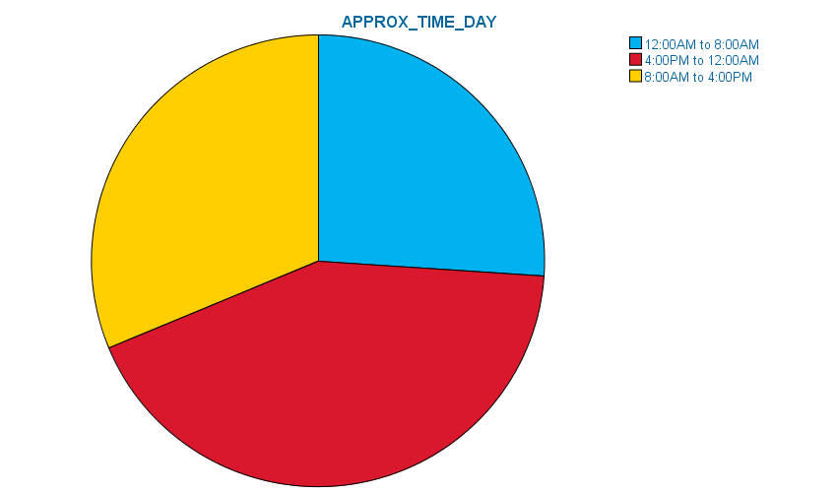

APPROX_TIME_DAYAPPROX_TIME_DAY, table, 1 levels of column headers and 2 levels of row headers, table with 6 columns and 6 rows
 |  | Frequency | Percent | Valid Percent | Cumulative Percent
Valid | 12:00AM to 8:00AM | 7098 | 26.1 | 26.1 | 26.1
Valid | 4:00PM to 12:00AM | 11601 | 42.6 | 42.6 | 68.7
Valid | 8:00AM to 4:00PM | 8508 | 31.3 | 31.3 | 100.0
Valid | Total | 27207 | 100.0 | 100.0

5. Do certain felony crimes occur more frequently during certain times of day?
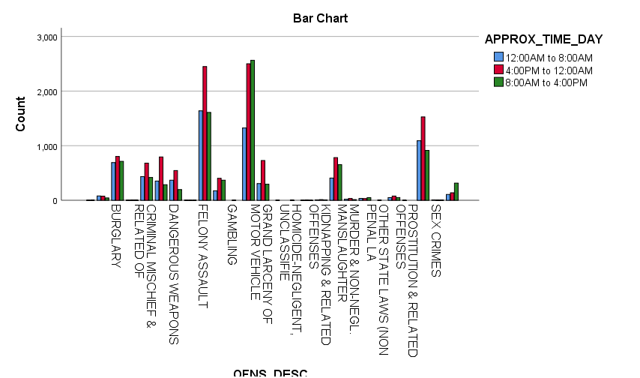
OFNS_DESC * APPROX_TIME_DAY CrosstabulationOFNS_DESC * APPROX_TIME_DAY Crosstabulation, table, Count, 1 layers, 2 levels of column headers and 2 levels of row headers, table with 6 columns and 31 rows
Count

 |  | APPROX_TIME_DAY |  |  | Total
 |  | 12:00AM to 8:00AM | 4:00PM to 12:00AM | 8:00AM to 4:00PM | Total
OFNS_DESC |  | 0 | 1 | 2 | 3
OFNS_DESC | ARSON | 80 | 77 | 43 | 200
OFNS_DESC | BURGLARY | 691 | 803 | 714 | 2208
OFNS_DESC | CHILD ABANDONMENT/NON SUPPORT | 1 | 2 | 2 | 5
OFNS_DESC | CRIMINAL MISCHIEF & RELATED OF | 433 | 681 | 418 | 1532
OFNS_DESC | DANGEROUS DRUGS | 353 | 794 | 286 | 1433
OFNS_DESC | DANGEROUS WEAPONS | 369 | 545 | 196 | 1110
OFNS_DESC | ENDAN WELFARE INCOMP | 1 | 1 | 1 | 3
OFNS_DESC | FELONY ASSAULT | 1638 | 2449 | 1609 | 5696
OFNS_DESC | FORGERY | 174 | 403 | 369 | 946
OFNS_DESC | GAMBLING | 0 | 1 | 0 | 1
OFNS_DESC | GRAND LARCENY | 1325 | 2500 | 2564 | 6389
OFNS_DESC | GRAND LARCENY OF MOTOR VEHICLE | 306 | 728 | 294 | 1328
OFNS_DESC | HOMICIDE-NEGLIGENT-VEHICLE | 0 | 1 | 0 | 1
OFNS_DESC | HOMICIDE-NEGLIGENT,UNCLASSIFIE | 0 | 2 | 0 | 2
OFNS_DESC | KIDNAPPING | 1 | 3 | 1 | 5
OFNS_DESC | KIDNAPPING & RELATED OFFENSES | 7 | 13 | 8 | 28
OFNS_DESC | MISCELLANEOUS PENAL LAW | 407 | 782 | 653 | 1842
OFNS_DESC | MURDER & NON-NEGL. MANSLAUGHTER | 20 | 34 | 13 | 67
OFNS_DESC | NYS LAWS-UNCLASSIFIED FELONY | 36 | 31 | 49 | 116
OFNS_DESC | OTHER STATE LAWS (NON PENAL LA | 0 | 3 | 0 | 3
OFNS_DESC | POSSESSION OF STOLEN PROPERTY | 49 | 78 | 51 | 178
OFNS_DESC | PROSTITUTION & RELATED OFFENSES | 1 | 0 | 0 | 1
OFNS_DESC | ROBBERY | 1091 | 1527 | 915 | 3533
OFNS_DESC | SEX CRIMES | 8 | 3 | 5 | 16
OFNS_DESC | THEFT-FRAUD | 107 | 139 | 315 | 561
Total |  | 7098 | 11601 | 8508 | 27207

6. How many crimes were completed? How many crimes were attempted?
They were 26197 completed an attempted were 1010. A percentage of 96.3 of 3.7.

CRM_ATPT_CPTD_CDCRM_ATPT_CPTD_CD, table, 1 levels of column headers and 2 levels of row headers, table with 6 columns and 5 rows
 |  | Frequency | Percent | Valid Percent | Cumulative Percent
Valid | ATTEMPTED | 1010 | 3.7 | 3.7 | 3.7
Valid | COMPLETED | 26197 | 96.3 | 96.3 | 100.0
Valid | Total | 27207 | 100.0 | 100.0

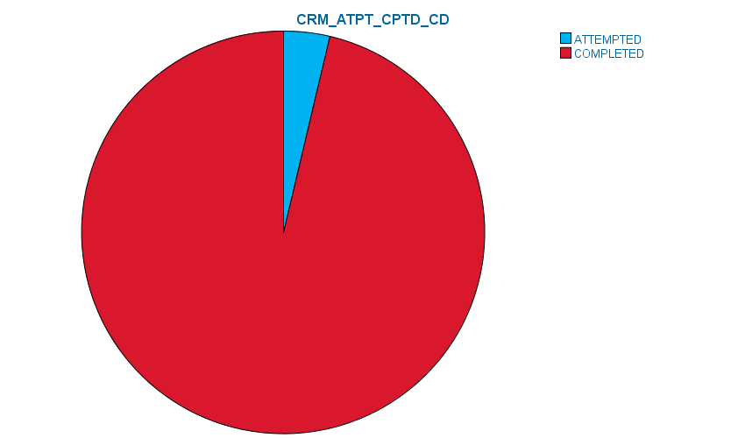

7. Which agencies are performing law enforcement activities in your borough?
86.6% is being done by N.Y. Police Dept then the next highest one is being done by N.Y. Housing Police 7.4 %, the next highest one if N.Y. Transit Police by 3.5%.

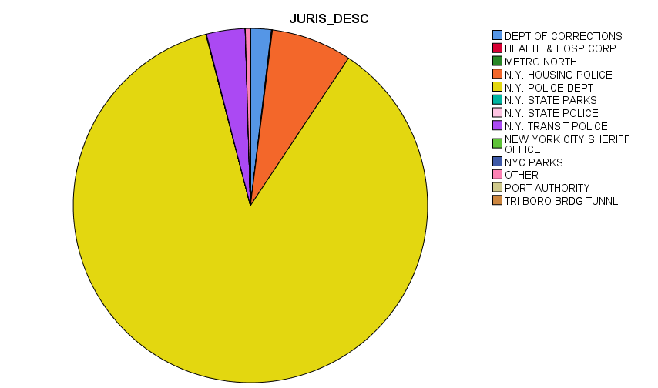

JURIS_DESCJURIS_DESC, table, 1 levels of column headers and 2 levels of row headers, table with 6 columns and 16 rows
 |  | Frequency | Percent | Valid Percent | Cumulative Percent
Valid | DEPT OF CORRECTIONS | 517 | 1.9 | 1.9 | 1.9
Valid | HEALTH & HOSP CORP | 22 | .1 | .1 | 2.0
Valid | METRO NORTH | 2 | .0 | .0 | 2.0
Valid | N.Y. HOUSING POLICE | 2000 | 7.4 | 7.4 | 9.3
Valid | N.Y. POLICE DEPT | 23565 | 86.6 | 86.6 | 96.0
Valid | N.Y. STATE PARKS | 7 | .0 | .0 | 96.0
Valid | N.Y. STATE POLICE | 8 | .0 | .0 | 96.0
Valid | N.Y. TRANSIT POLICE | 957 | 3.5 | 3.5 | 99.5
Valid | NEW YORK CITY SHERIFF OFFICE | 2 | .0 | .0 | 99.5
Valid | NYC PARKS | 2 | .0 | .0 | 99.5
Valid | OTHER | 120 | .4 | .4 | 100.0
Valid | PORT AUTHORITY | 1 | .0 | .0 | 100.0
Valid | TRI-BORO BRDG TUNNL | 4 | .0 | .0 | 100.0
Valid | Total | 27207 | 100.0 | 100.0

8. What were some of the types and amounts of offenses the agencies were involved in investigating?

OFNS_DESC * JURIS_DESC CrosstabulationOFNS_DESC * JURIS_DESC Crosstabulation, table, Count, 1 layers, 2 levels of column headers and 2 levels of row headers, table with 16 columns and 31 rows
Count

 |  | JURIS_DESC |  |  |  |  |  |  |  |  |  |  |  |  | Total
 |  | DEPT OF CORRECTIONS | HEALTH & HOSP CORP | METRO NORTH | N.Y. HOUSING POLICE | N.Y. POLICE DEPT | N.Y. STATE PARKS | N.Y. STATE POLICE | N.Y. TRANSIT POLICE | NEW YORK CITY SHERIFF OFFICE | NYC PARKS | OTHER | PORT AUTHORITY | TRI-BORO BRDG TUNNL | Total
OFNS_DESC |  | 0 | 0 | 0 | 0 | 3 | 0 | 0 | 0 | 0 | 0 | 0 | 0 | 0 | 3
OFNS_DESC | ARSON | 8 | 0 | 0 | 81 | 54 | 0 | 0 | 0 | 0 | 0 | 57 | 0 | 0 | 200
OFNS_DESC | BURGLARY | 0 | 0 | 0 | 116 | 2085 | 0 | 0 | 5 | 0 | 0 | 2 | 0 | 0 | 2208
OFNS_DESC | CHILD ABANDONMENT/NON SUPPORT | 0 | 0 | 0 | 0 | 5 | 0 | 0 | 0 | 0 | 0 | 0 | 0 | 0 | 5
OFNS_DESC | CRIMINAL MISCHIEF & RELATED OF | 9 | 0 | 1 | 119 | 1251 | 1 | 0 | 145 | 0 | 0 | 6 | 0 | 0 | 1532
OFNS_DESC | DANGEROUS DRUGS | 1 | 1 | 0 | 127 | 1278 | 0 | 3 | 11 | 1 | 1 | 10 | 0 | 0 | 1433
OFNS_DESC | DANGEROUS WEAPONS | 0 | 0 | 0 | 147 | 921 | 0 | 0 | 41 | 0 | 0 | 0 | 0 | 1 | 1110
OFNS_DESC | ENDAN WELFARE INCOMP | 0 | 0 | 0 | 0 | 3 | 0 | 0 | 0 | 0 | 0 | 0 | 0 | 0 | 3
OFNS_DESC | FELONY ASSAULT | 272 | 13 | 0 | 589 | 4730 | 0 | 1 | 60 | 1 | 1 | 28 | 0 | 1 | 5696
OFNS_DESC | FORGERY | 0 | 0 | 1 | 38 | 606 | 2 | 2 | 296 | 0 | 0 | 0 | 0 | 1 | 946
OFNS_DESC | GAMBLING | 0 | 0 | 0 | 0 | 1 | 0 | 0 | 0 | 0 | 0 | 0 | 0 | 0 | 1
OFNS_DESC | GRAND LARCENY | 1 | 7 | 0 | 228 | 5853 | 0 | 0 | 292 | 0 | 0 | 8 | 0 | 0 | 6389
OFNS_DESC | GRAND LARCENY OF MOTOR VEHICLE | 0 | 0 | 0 | 40 | 1288 | 0 | 0 | 0 | 0 | 0 | 0 | 0 | 0 | 1328
OFNS_DESC | HOMICIDE-NEGLIGENT-VEHICLE | 0 | 0 | 0 | 0 | 1 | 0 | 0 | 0 | 0 | 0 | 0 | 0 | 0 | 1
OFNS_DESC | HOMICIDE-NEGLIGENT,UNCLASSIFIE | 0 | 0 | 0 | 0 | 2 | 0 | 0 | 0 | 0 | 0 | 0 | 0 | 0 | 2
OFNS_DESC | KIDNAPPING | 0 | 0 | 0 | 0 | 5 | 0 | 0 | 0 | 0 | 0 | 0 | 0 | 0 | 5
OFNS_DESC | KIDNAPPING & RELATED OFFENSES | 0 | 0 | 0 | 3 | 25 | 0 | 0 | 0 | 0 | 0 | 0 | 0 | 0 | 28
OFNS_DESC | MISCELLANEOUS PENAL LAW | 208 | 0 | 0 | 194 | 1418 | 0 | 2 | 12 | 0 | 0 | 6 | 1 | 1 | 1842
OFNS_DESC | MURDER & NON-NEGL. MANSLAUGHTER | 0 | 0 | 0 | 9 | 58 | 0 | 0 | 0 | 0 | 0 | 0 | 0 | 0 | 67
OFNS_DESC | NYS LAWS-UNCLASSIFIED FELONY | 0 | 1 | 0 | 8 | 104 | 3 | 0 | 0 | 0 | 0 | 0 | 0 | 0 | 116
OFNS_DESC | OTHER STATE LAWS (NON PENAL LA | 0 | 0 | 0 | 0 | 3 | 0 | 0 | 0 | 0 | 0 | 0 | 0 | 0 | 3
OFNS_DESC | POSSESSION OF STOLEN PROPERTY | 0 | 0 | 0 | 8 | 166 | 0 | 0 | 3 | 0 | 0 | 1 | 0 | 0 | 178
OFNS_DESC | PROSTITUTION & RELATED OFFENSES | 0 | 0 | 0 | 0 | 1 | 0 | 0 | 0 | 0 | 0 | 0 | 0 | 0 | 1
OFNS_DESC | ROBBERY | 2 | 0 | 0 | 245 | 3191 | 1 | 0 | 92 | 0 | 0 | 2 | 0 | 0 | 3533
OFNS_DESC | SEX CRIMES | 16 | 0 | 0 | 0 | 0 | 0 | 0 | 0 | 0 | 0 | 0 | 0 | 0 | 16
OFNS_DESC | THEFT-FRAUD | 0 | 0 | 0 | 48 | 513 | 0 | 0 | 0 | 0 | 0 | 0 | 0 | 0 | 561
Total |  | 517 | 22 | 2 | 2000 | 23565 | 7 | 8 | 957 | 2 | 2 | 120 | 1 | 4 | 27207

